**LAB 6: DHCP and Subnetting**

**THEORY:**

A network protocol called DHCP is used to automatically assign IP addresses and other network configuration parameters to devices (clients) on a network, such as the subnet mask, default gateway, and DNS server. As a result, a network administrator is no longer required to manually assign IP addresses.

The process of breaking up a big IP network into smaller, easier-to-manage sub-networks (subnets) is called subnetting. By lowering broadcast domains, this enhances network security and performance.In this:

* **Subnet Mask:** Determines the network and host portions of an IP address.  
  Example: 255.255.255.0 (or /24) means the first 24 bits are the network part.
* **Network ID:** Identifies the subnet.
* **Host ID:** Identifies devices within the subnet.

**Lab Setup:**

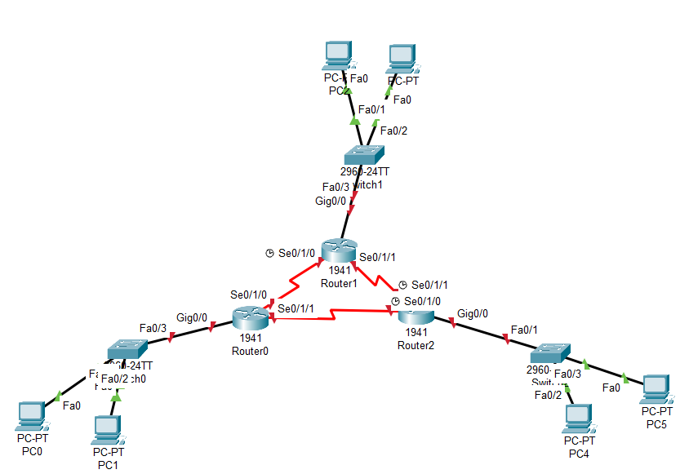

The primary network address, 192.168.0.0/24, was provided to us for this lab, and we were required to split it up into six subnetworks according to the number of hosts required in each. We started by examining the number of hosts needed by each network. We determined the Broadcast ID (BID), the range of valid host IPs, and the Network ID (NID) for every subnet. We were able to assign routers and PCs the proper IP addresses thanks to these values. All devices were appropriately assigned within their respective networks, and no IP addresses were wasted thanks to this planned subnetting.

|  |  |  |  |  |  |
| --- | --- | --- | --- | --- | --- |
| Network | Host Needed | Subnet Mask | NID | Valid Host range | BID |
| N1 | 20 | 255.255.255.224 | 192.168.1.0 | 192.168.1.1– 192.168.1.30 | 192.168.1.31 |
| N2 | 10 | 255.255.255.240 | 192.168.1.32 | 192.168.1.33– 192.168.1.46 | 192.168.1.47 |
| N3 | 4 | 255.255.255.248 | 192.168.1.48 | 192.168.1.49–192.168.1.54 | 192.168.1.55 |
| N4 | 2 | 255.255.255.252 | 192.168.1.56 | 192.168.1.57– 192.168.1.58 | 192.168.1.59 |
| N5 | 2 | 255.255.255.252 | 192.168.1.60 | 192.168.1.61– 192.168.1.62 | 192.168.1.63 |
| N6 | 2 | 255.255.255.252 | 192.168.1.64 | 192.168.1.65– 192.168.1.66 | 192.168.1.67 |

**For Router 0,**

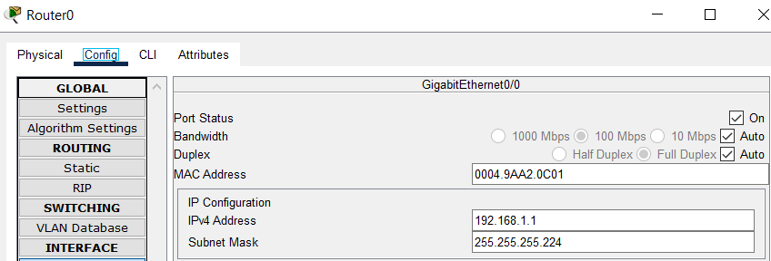

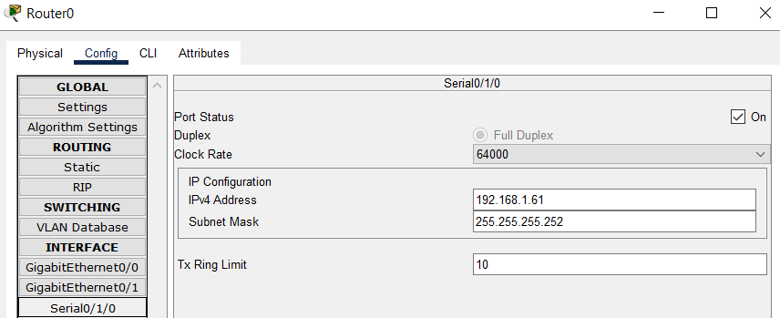

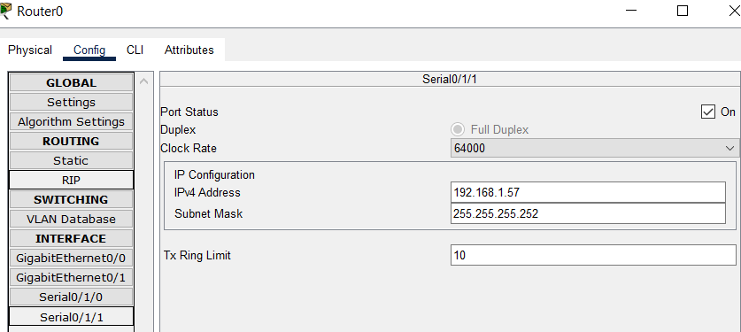

Similar setup was done on other routers.

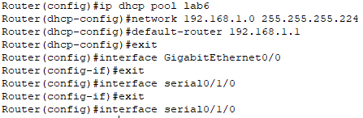

Then this configuration tells the router to:

* Create a DHCP pool named lab6
* Assign IPs from 192.168.1.1 to 192.168.1.30
* Use 192.168.1.1 as the default gateway for clients

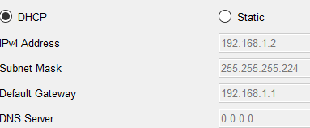

Hence, ip addresses were automatically assigned to PCs.

Then we defined static routes to each router to add a route required to follow and reach the required node. This is done for each routers as follows:

**Static routes for router 0,**

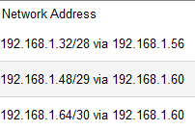

**Static routes for router 1,**

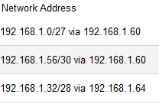

**Static routes for router 2,**

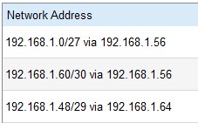

Then, we test the connection by tracing from PC1 to PC3

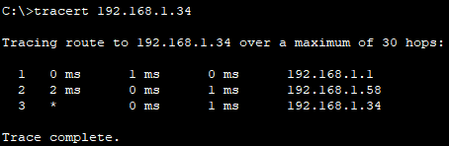

**DISCUSSION:**

In order to automate IP address assignments, we successfully implemented DHCP in this lab. This eliminated the need for manual IP assignment for every host, greatly simplifying the network configuration process. Based on host requirements, the subnetting task entailed dividing the primary network, 192.168.0.0/24, into six subnetworks. To avoid IP waste and guarantee that each subnet had enough IPs for the necessary hosts, each subnet was meticulously designed using the proper subnet mask. To guarantee that every subnet could speak with every other subnet, static routing was also set up on every router. We made sure that data packets could move through the network properly by manually creating routes.

**CONCLUSION:**

The lab verified how well subnetting and DHCP work to streamline network administration and boost efficiency.